This Agreement is made on DATE by ALISON JOSE t/a CIRCULAR CENTRE PTY LTD / STSC. Sustainable Textile Supply Chain (the "Disclosing Party"), whose address is 1 Merton Street, Stanmore NSW 2048, Australia, and YOUR NAME (the "Receiving Party") whose address is Address of Receiving Party.
The parties hereby agree as follows:
In its sole discretion, the Disclosing Party will provide to the Receiving Party certain confidential and proprietary information for the limited purpose of allowing the Receiving Party to conduct its Business for the purposes of direct communication and ordering products or service via STSC and with any associated third-party suppliers, in accordance with the following terms and conditions:
1. Definition
For purposes of this Agreement, "Confidential Information" shall mean the information received by the Receiving Party from the Disclosing Party from this date forward is marked known as "Confidential" and "Proprietary" or which would logically be considered "Confidential" and/or "Proprietary" in view of its relationship to the whole disclosure. Information furnished orally, in written for, by electronic means, or by any other means is identified by the Disclosing Party as confidential and proprietary at the time of disclosure and shall be treated by the Receiving Party as Confidential Information.
2. Protection and Purpose
All "Confidential Information" shall be maintained in confidence by the Receiving Party and shall not be disclosed to any third party and shall be protected with the same degree of care as the Receiving Party normally uses in the protection of its own confidential and proprietary information, but in no case with any less degree than reasonable care. The Receiving Party shall not use any "Confidential Information" received from the Disclosing Party except for the purposes set forth above.

The Receiving Party shall not use any information received by The Disclosing Party to place orders of any kind direct with the third-party supplier or any associated businesses or individual connected to STSC’s supplier. This includes specific information on textile manufacturers and specifically blends under the name of CircStretch made with Roica V550 yarn.
3. Restrictions
The restrictions herein provided shall not apply with respect to "Confidential Information" which:

- Is known by the Receiving Party at the time of receipt and provides evidence to The Disclosing Party; or
- Is or becomes a part of the public domain without breach of this Agreement by the Receiving Party; or
- Is disclosed pursuant to judicial action or government regulations, provided the Receiving Party notifies the Disclosing Party prior to such disclosure and cooperates with the Disclosing Party in the event the Disclosing Party elects to legally contest and avoid such disclosure.

4. Rights and Licenses
This Agreement and the furnishing of "Confidential Information" as provided herein shall not be construed as establishing, either expressly or by implication, any grant of rights or licenses to the Receiving Party or any relationship between all parties.

5. Ownership
All tangible information, including emails, correspondence plus specific information regarding the textiles and blends in the STSC textiles collection and other information submitted hereunder by the Disclosing Party to the Receiving Party, shall remain the property of the Disclosing Party. The Receiving Party is prohibited to pursue any further business undertaking, with any related third-party disclosed and related to "Confidential Information".
6. Export
The Receiving Party shall not export any Confidential Information without written permission from the Disclosing Party. This includes confidential information about the textiles and blends in the STSC textiles collection.

7. Additional Provisions

The undersigned agrees not to disclose or independently act on information supplied by the Disclosing Party or discovered in relation to working with the Disclosing Party pertaining to any person, business or organisation related to the Disclosing Party from their supply chain including and specific to any Textile Mill working with STSC that reside internationally. This includes agreeing to not disclose nor manufacture textiles that are in the CircStretch collection specifically using ROICA V550.
8. Length of Contract for NDA /Termination
This Agreement is to be construed in accordance with the laws pertaining to Intellectual Property and shall terminate six (6) years from the effective date of this Agreement.

DISCLOSING PARTY NAME
ALISON JOSE, DIRECTOR. CIRCULAR CENTRE PTY LTD

Date: /2022
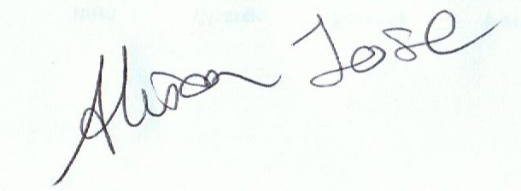
RECEIVING PARTY NAME
Name:
EMAIL.

Date:

Please return to Alison Jose at contact@sustainabletextiles.club

